Indira Gandhi Delhi Technical University for Women

(Established by Govt. of Delhi vide Act 09 of 2012)
Kashmere Gate, Delhi – 110006


Practical File

Open Source Technologies
Name : Yashika Malik
Enrollment Number : 22701172024

Experiment 1

Objective:
To understand the basics of Git and GitHub and set up a GitHub account and repository.
Software/Tools Required:
Git, GitHub account, Web browser, Command Line / Terminal
Theory Overview:
Git is a distributed version control system that helps track changes in files and source code during software development. It allows users to create repositories, manage versions through commits, and revert to previous states when required. Git supports efficient collaboration by enabling multiple users to work on the same project without conflicts.
GitHub is a web-based hosting service for Git repositories that provides remote storage, version control, and collaboration features such as branching, merging, and issue tracking. Together, Git and GitHub make project management more organized, reliable, and efficient.
Procedure:
1. Create an account on GitHub.
2. Install Git on the system.
3. Configure Git with username and email.
4. Create a new repository on GitHub.
5. Clone or initialize the repository locally.
6. Create a README file and push it to GitHub.
Code:
git config --global user.name “Yashika Malik"
git config --global user.email "yashikamalik1006@gmail.com"
git init
git add README.md
git commit -m "Initial commit"
git push origin main
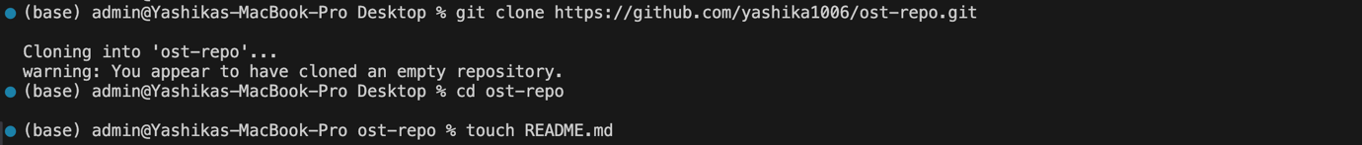
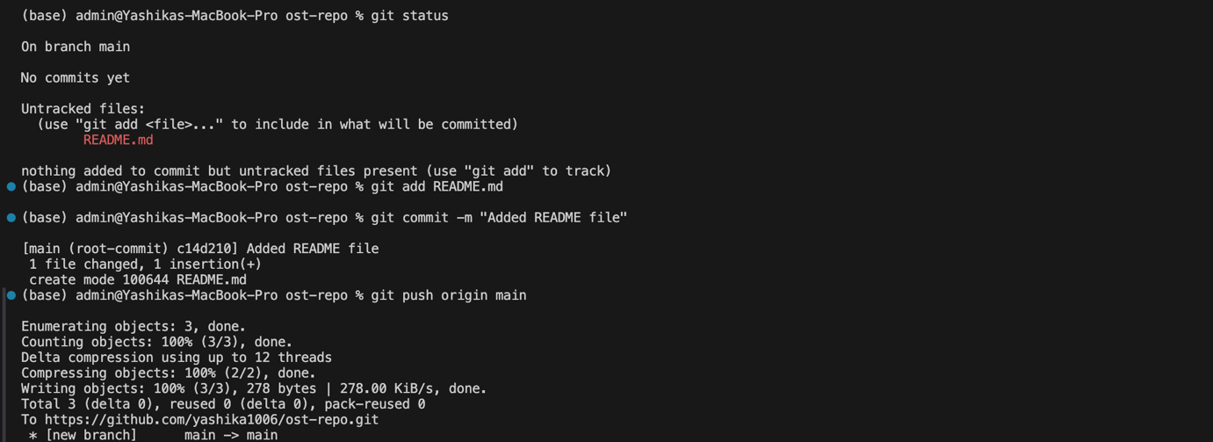

Output:
A GitHub repository is successfully created with a README file pushed to it.

Experiment 2

Objective:
To learn how to initialize a local Git repository and track changes.
Software/Tools Required:
Git, Command Line / Terminal, Text Editor
Theory Overview:
A local Git repository helps in tracking changes in files over time. Commits store snapshots of the project, allowing users to revert to previous versions if required.
Procedure:
1. Create a new folder.
2. Initialize a Git repository.
3. Create a sample file.
4. Add the file to staging area.
5. Commit the changes.
6. View commit history.
Code:
touch sample_code.cpp
git add.
git commit -m "added sample file"

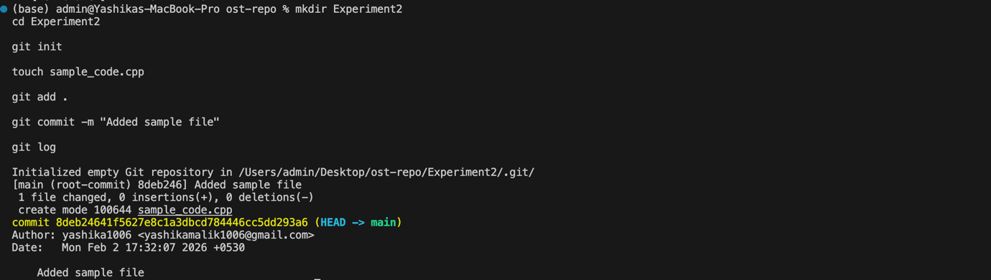

Output:
The file is tracked by Git and commit history is displayed.

Experiment 3

Objective:
To collaborate using GitHub and manage multiple branches.
Software/Tools Required:
Git, GitHub, Command Line / Terminal
Theory Overview:
Branches allow developers to work on different features independently. Merging combines changes from different branches into the main branch.
Procedure:
1. Create a new branch.
2. Switch to the new branch.
3. Make changes and commit.
4. Switch back to main branch.
5. Merge the branch.
6. Push changes to GitHub.
Code:
git branch
git checkout -b temp-branch
git add .
git commit -m "experiment"
git checkout main
git merge temp-branch
git push origin main
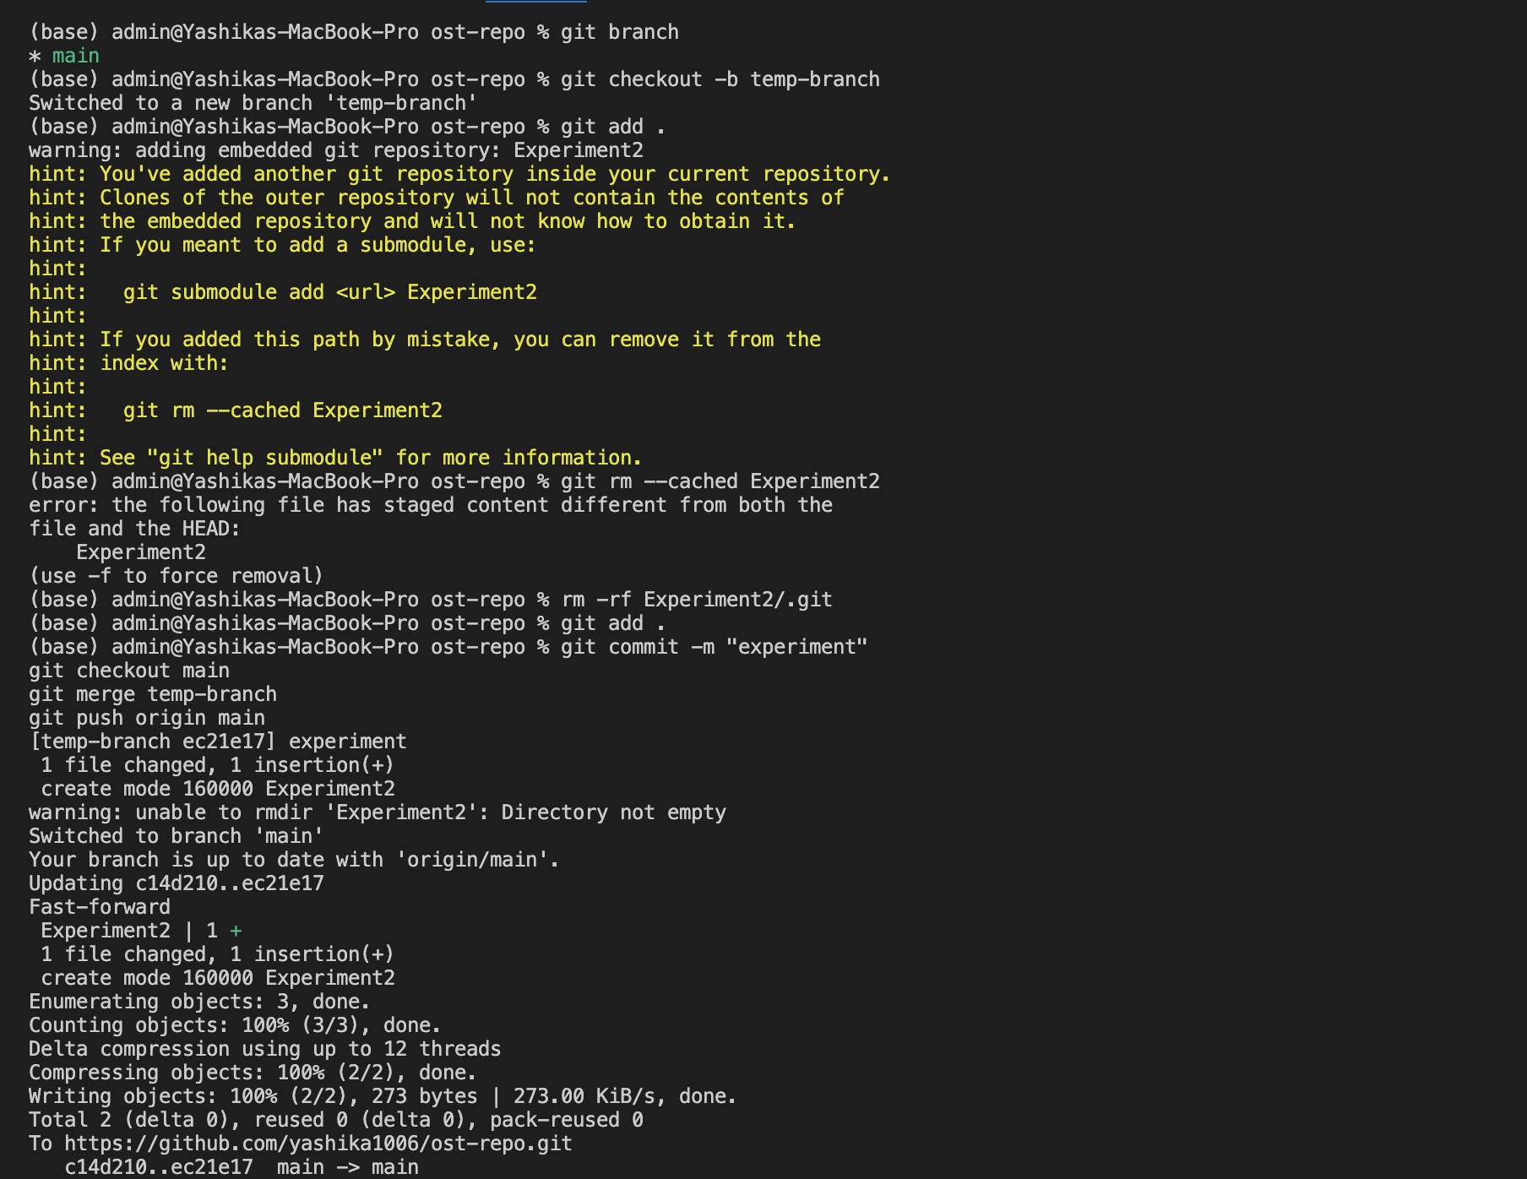

Output: Branch is successfully merged and changes are pushed to remote repository

Experiment 4
Objective:
To learn how to handle merge conflicts using Git.
Software/Tools Required:
Git, Command Line / Terminal, Text Editor
Theory Overview:
Merge conflicts occur when multiple branches modify the same part of a file. Git requires manual intervention to resolve such conflicts.
Procedure:
1. Create two branches.
2. Modify the same file in both branches.
3. Attempt to merge branches.
4. Resolve conflicts manually.
5. Commit the resolved changes.
Code:
git checkout -b branch1
git commit -am "Branch1 changes"
git checkout main
git checkout -b branch2
git commit -am "Branch2 changes"
git checkout main
git merge branch1
git merge branch2
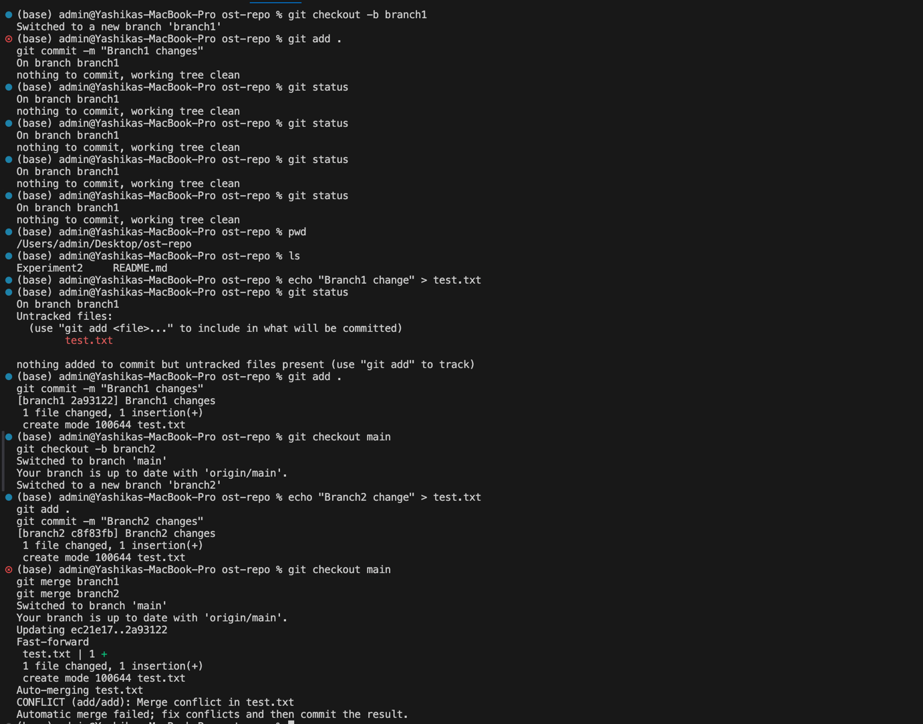

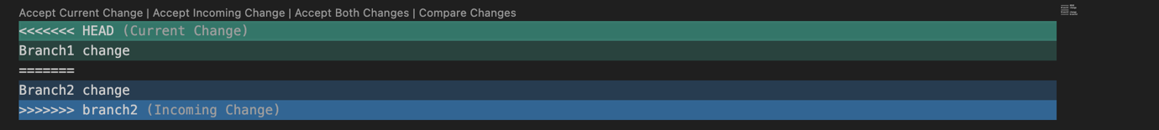

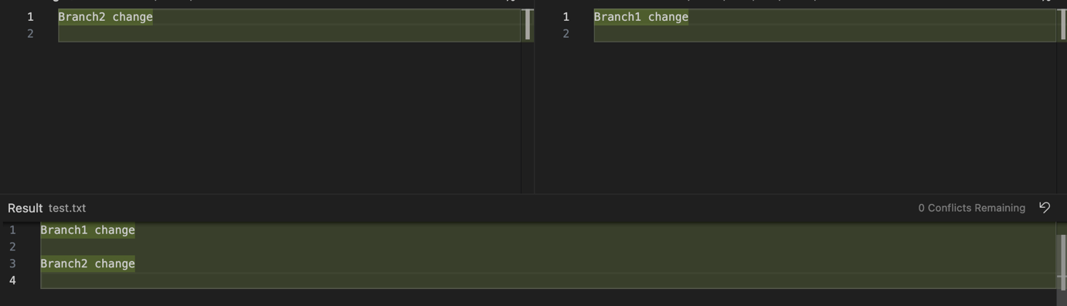

Output:
Merge conflict is resolved successfully and final changes are committed.

Experiment 5

Objective: To understand collaborative workflows using GitHub, including forking, cloning, and pull requests.

Software/Tools Required: Git, GitHub, Command Line / Terminal, Web Browser

Theory Overview: Forking creates a personal copy of another user’s repository on GitHub. Cloning downloads that repository to the local system. A pull request is used to propose changes made in the forked repository to the original repository.

Procedure:
- Fork a public repository from GitHub.
- Clone the forked repository to the local system.
- Create a new branch.
- Make changes in the repository.
- Commit and push changes to GitHub.
- Create a pull request to the original repository.

Code: git clone <repository-url>
cd repo-name
git checkout -b my-branch
git add .
git commit -m "Made changes"
git push origin my-branch

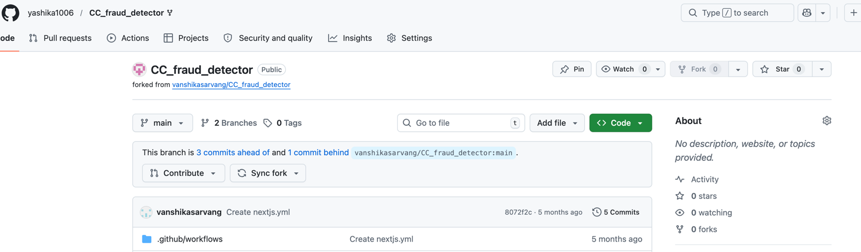clone: git clone https://github.com/yashika1006/CC_fraud_detector

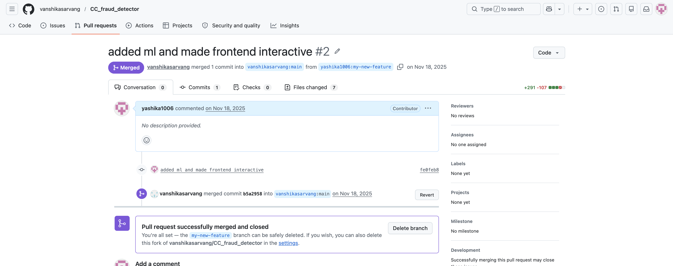

Output: The repository was successfully forked and cloned. Changes were made in a new branch and a pull request was created successfully.

